# Lab Task 5: CGF

## 5.1. Select one algorithm.

Binary Search Algorithm.

## 5.2. Code of Algorithm.

import java.util.Scanner;

import java.util.Arrays;

public class BinarySearch{

public static void main(String args[]){

int[] arr = {64, 34, 25, 12, 22, 11, 90};

int[] newarr = sortArr(arr);

printArr(newarr);

Scanner input=new Scanner(System.in);

System.out.println("Enter key to search.");

int key=input.nextInt();

binarySearch(newarr,key);

}

public static int[] sortArr(int[] arr) {

Arrays.sort(arr);

return arr;

}

public static void printArr(int[] arr) {

for (int num : arr) {

System.out.print(num + " ");

}

System.out.println();

}

public static void binarySearch(int[] arr, int key){

int start=0;

int end=arr.length-1;

int mid =0;

while(start<end){

mid=start+(end-start)/2;

if(arr[mid]==key){

System.out.println("Key Found!");

return ;

}

else if(arr[mid]<key){

start=mid+1;

}

else {

end=mid-1;

}

}

System.out.println("Key not found in array");

}

}

## 5.3. Control Flow Graph.

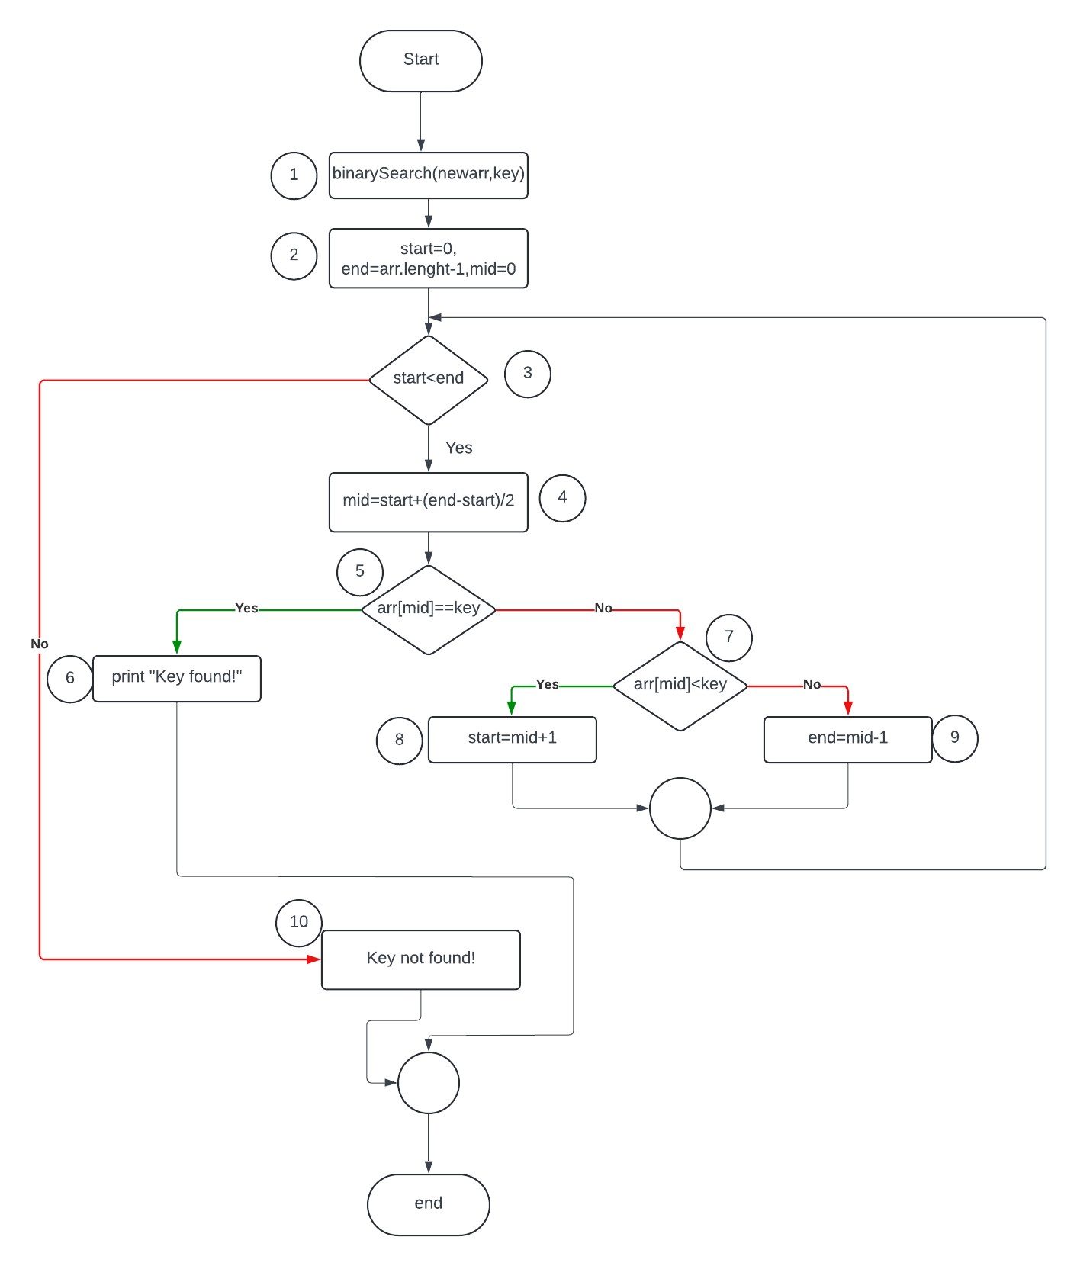

## 5.4. Paths in CGF

1. 1-2-3-4-5-6
2. 1-2-3-4-5-7-8-3-4-5-6
3. 1-2-3-4-5-7-9-3-4-5-6
4. 1-2-3-4-5-7-8-10
5. 1-2-3-4-5-7-9-10

## Test data for each path.

|  |  |
| --- | --- |
| Paths | Test Data |
| Path 1 | Array= [11, 12, 22, 25, 34, 64, 90], key =25 |
| Path 2 | Array= [11, 12, 22, 25, 34, 64, 90], key=64 |
| Path 3 | Array= [11, 12, 22, 25, 34, 64, 90], key=12 |
| Path 4 | Array= [11, 12, 22, 25, 34, 64, 90], key=80 |
| Path 5 | Array= [11, 12, 22, 25, 34, 64, 90], key=13 |

## Test Cases for each path.

|  |  |  |  |  |  |
| --- | --- | --- | --- | --- | --- |
| Test ID | Description | Input data | Expected Outcome | Actual Outcome | Status |
| TC_01 | To find an integer in an array that exits in middle of the array after sorting | Array= [11, 12, 22, 25, 34, 64, 90],  key =25 | “Key found” message should be displayed. |  |  |
| TC_02 | To find an integer in an array that is greater than the middle element of given array | Array= [11, 12, 22, 25, 34, 64, 90], key=64 | “Key found” message should be displayed. |  |  |
| TC_03 | To find an integer in an array that is smaller than the middle element of given array | Array= [11, 12, 22, 25, 34, 64, 90], key=12 | “Key found” message should be displayed. |  |  |
| TC_04 | Validates the behavior when searching for an integer that is greater than the middle element but does not exist in the array. | Array= [11, 12, 22, 25, 34, 64, 90], key=80 | “Key not found” message should be displayed. |  |  |
| TC_05 | Validates the behavior when searching for an integer that is smaller than the middle element but does not exist in the array. | Array= [11, 12, 22, 25, 34, 64, 90], key=13 | “Key not found” message should be displayed. |  |  |

## Code execution results according to test cases.

### TC_01:

### TC_02:

### TC_03:

### TC_04:

### TC_05:

